**Day 1 08Aug2023 Vinuth kumar 28323**

**HTML**

**TASK 1**

<!DOCTYPE html>

<html>

<head>

<style>

table, th, td {

border: 1px solid black;

}

</style>

<title> HTML Page Title</title>

</head>

<body>

<center> <h1> HELLO WORLD</h1> </center>

<p> HI IM <b>VINUTH</b> IM WORKING IN <i>company</i> </p>

<img src="C:\Users\Socgen\Downloads\tree.jfif" width="500px"><br>

</body>

**OUTPUT**

**TASK 2**

TASK 2:

elements : HTML element is everything from the start tag to the end tag.

<!DOCTYPE html>

<html>

<body>

<h1>My First Heading</h1>

<p>My first paragraph.</p>

</body>

</html>

attributes : HTML attributes provide additional information about HTML elements.

style attribute

<p style="color:red;">This is a red paragraph.</p>

styles : HTML style attribute is used to add styles to an element, such as color, font, size etc.

<body style="background-color:powderblue;">

**TASK 3**

<!DOCTYPE html>

<html>

<head>

<table>

<tr>

<th>sr.no</th>

<th>name</th>

<th>age</th>

<th>contact</th>

</tr><br>

<tr>

<td>1</td>

<td>vinuth</td>

<td>22 </td>

<td>9983883838</td>

</tr>

<tr>

<td>2</td>

<td>aditya</td>

<td>22 </td>

<td>9848484877</td>

</tr>

<tr>

<td>3</td>

<td>niranjan</td>

<td>22 </td>

<td>9983838383</td>

</tr>

</table><br>

</body>

</html>

**OUTPUT**

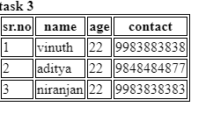

**TASK 4**

<!DOCTYPE html>

<html>

<head>

<form>

<label for="firstname">firstname: </label>

<input type = "text" name="firstname" id="firstname"><br>

<br>

<label for="firstname">lastname: </label>

<input type = "text" name="lastname" id="lastname"><br>

<br>

<input type="submit" value="Submit">

</form><br>

</body>

</html>

**Output**

**Task 5**

<!DOCTYPE html>

<html>

<head>

<form>

<fieldset>

<legend> required info </legend>

<label for="firstname">firstname: </label>

<input type = "text" name="firstname" id="firstname"><br>

<br>

<label for="lastname">lastname: </label>

<input type = "text" name="lastname" id="lastname"><br>

<br>

<label for="email">email: </label>

<input type = "text" name="email" id="email"><br>

<br>

<input type="submit" value="Submit">

</fieldset><br>

<div>

<select name = "country">

<option value = "india">india</option>

<option value = "france" selected >france</option>

<option value = "germany" >germany</option>

</select>

</div><br>

<div>

<label for="message">message:</label>

<textarea id="message" name="message" rows="10" cols="50" maxlength="50" placeholder="message"> please type here</textarea

</div><br>

<br>

<div><br>

what is your gender?

<br>

male <input type= "radio" name = "gender" value="male">

female <input type= "radio" name = "gender" value="female">

others <input type= "radio" name = "gender" value="others">

</div><br>

<form action="/action_page.php" method="get">

<label for="location">Choose your location from the list:</label>

<input list="browsers" name="browser" id="browser">

<datalist id="browsers">

<option value="india">

<option value="germany">

<option value="Chicago">

<option value="china">

<option value="russia">

</datalist>

<input type="submit">

</form>

<form>

<label for="cars">Choose a car:</label>

<select name="cars" id="cars">

<optgroup label="Swedish Cars">

<option value="volvo">Volvo</option>

<option value="saab">Saab</option>

</optgroup>

<optgroup label="German Cars">

<option value="mercedes">Mercedes</option>

<option value="audi">Audi</option>

</optgroup>

<input type="submit">

</select>

<br><br>

</form>

<br>

<h1>amount of car in range</h1>

<form oninput="x.value=parseInt(a.value)+parseInt(b.value)">

<input type="range" id="a" value="500000000">

+<input type="number" id="b" value="250000">

=<output name="x" for="a b"></output>

</form><br>

<div>

do you agree this form?

<input type="checkbox" name="tos" value="yes">

</div>

</form><br>

</body>

</html>

**Output :**

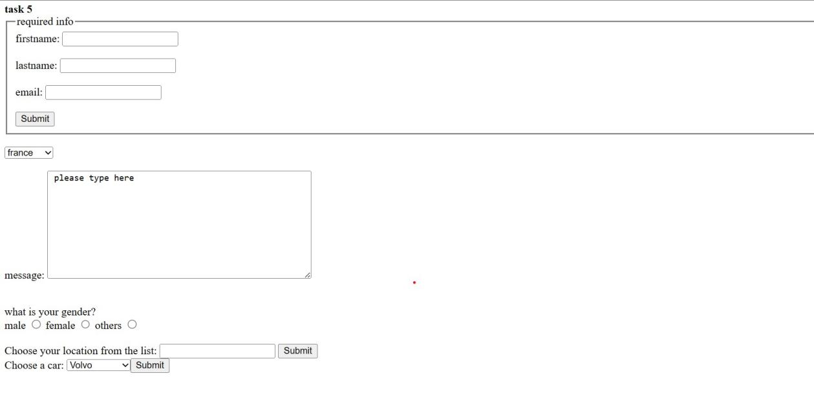

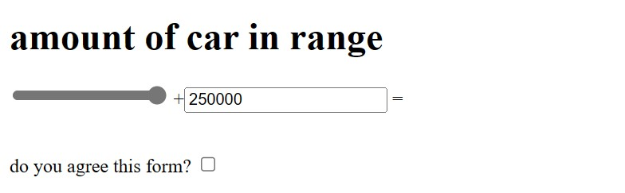

**Task 6:**

HTML5 is a new version of HTML with new functionalities with markup language with Internet technologies.

HTML5 supports both video and audio.

features :

Intro of audio and video

Vector Graphics

Header and Footer

Figure and Figcaption

**Task 7:**

<marquee width="60%" direction="right" height="50%">

Please give the info

</marquee><br>

**Output:**

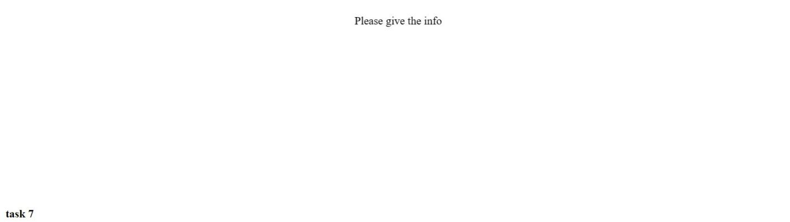

**Task 8:**

<!DOCTYPE html>

<html>

<head>

<h2>An unordered HTML list</h2>

<ul>

<li>Coffee</li>

<li>Tea</li>

<li>Milk</li>

</ul>

<br>

<h3>An ordered HTML list</h3>

<ol>

<li>Coffee</li>

<li>Tea</li>

<li>Milk</li>

</ol>

</body>

</html>

**Output:**

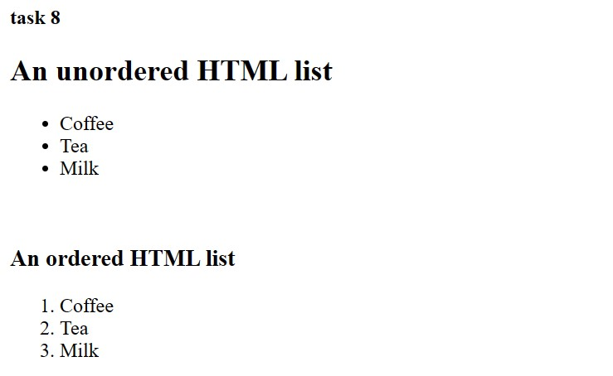

**Task 9:**

<!DOCTYPE html>

<html>

<body>

<h1>The audio element</h1>

<p>Click on the play button to play a sound:</p>

<audio controls>

<source src="goku.ogg" type="audio/ogg">

<source src="goku.mp3" type="audio/mpeg">

</audio><br>

<h1>The video element</h1>

<video width="320" height="240" controls>

<source src="movie.mp4" type="video/mp4">

<source src="movie.ogg" type="video/ogg">

</video><br>

</body>

</html>

**Output:**

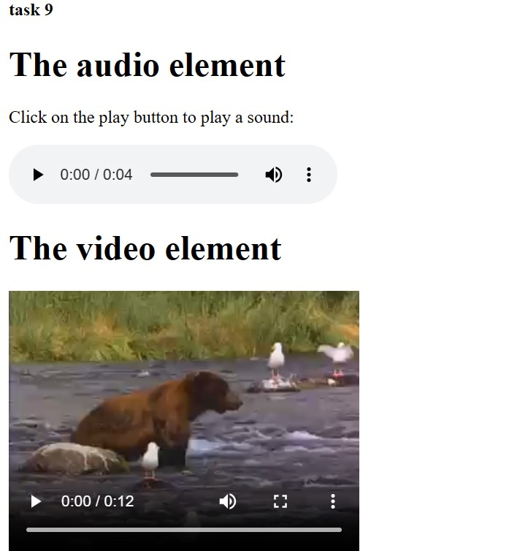

**Task 10:**

<!DOCTYPE html>

<html>

<body>

<h4>remove the iframe border</h4>

<p>to remove the default border of the iframe</p>

<iframe src="E:\vinuth\tree.jfif"> title="front image"></iframe>

<p><a href="https://www.google.com" target="iframe_a">google</a></p>

</body>

</html><br>

**Output:**

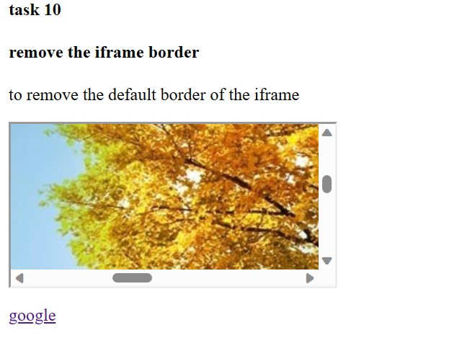

**Task 11:**

<!DOCTYPE HTML>

<html>

<head>

<style>

#div1 {

width: 320px;

height: 70px;

padding: 10px;

border: 1px solid #aaaaaa;

}

</style>

<script>

function allowDrop(ev) {

ev.preventDefault();

}

function drag(ev) {

ev.dataTransfer.setData("text", ev.target.id);

}

function drop(ev) {

ev.preventDefault();

var data = ev.dataTransfer.getData("text");

ev.target.appendChild(document.getElementById(data));

}

</script>

</head>

<body>

<p>Drag the image into the rectangle:</p>

<div id="div1" ondrop="drop(event)" ondragover="allowDrop(event)"></div>

<br>

<img id="drag1" src="E:\vinuth\tree.jfif" width="100px">

</body>

</html><br>

**Output:**

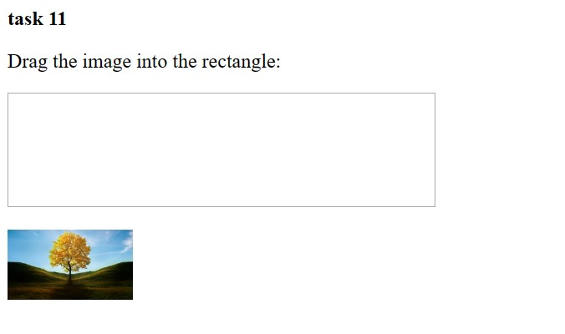

**Task 12:**

<!DOCTYPE html>

<html>

<body>

<h1>The form autocomplete attribute</h1>

<p>Fill in and submit the form, then reload the page, start to fill in the form again - and see how autocomplete works.</p>

<p>Then, try to set autocomplete to "on".</p>

<form action="/action_page.php" autocomplete="on">

<label for="fname">First name:</label>

<input type="text" id="fname" name="fname"><br><br>

<label for="email">Email:</label>

<input type="text" id="email" name="email"><br><br>

<input type="submit" value="Submit">

</form>

</body>

</html>

**Output:**

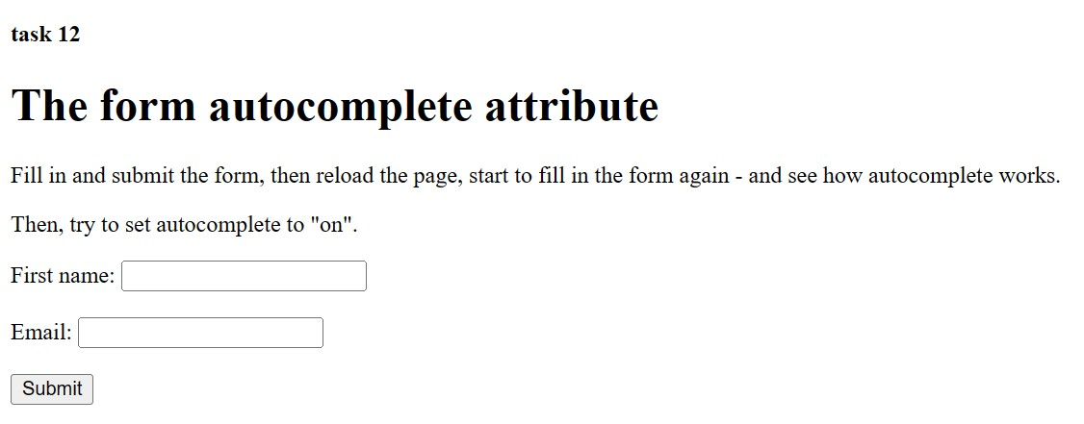

**Task 13:**

What are 2 types of tags in HTML?

1. paired tags

2.unpaired tags

**Task 14:**

Why do we use POST and GET ? Write a code Snippet for the same

POST

POST for destructive actions such as creation (I'm aware of the irony), editing, and deletion, because you can't hit a POST action in the address bar of your browser.

POST /test/demo_form.php HTTP/1.1

Host: w3schools.com

name1=value1&name2=value2

GET

GET is used to request data from a specified resource.

/test/demo_form.php?name1=value1&name2=value2

**CSS**

**Task 1:**

What are Selector? describe the Types of Selectors.

ans:

selectors in html which selects html elements which can be used for styling and sizing etc .

TYPES

1. COMBINATOR SELETORS

2. SIMPLE SELECTORS

3. PSEUDO-CLASS SELECTORS

4. PSEUDO-ELEMENT SELECTORS

5. ATTRIBUTE SELECTORS

**Task 2:**

<!DOCTYPE html>

<html>

<head>

<style>

p{

text-align: center;

color: blue;

}

</style>

<title> CSS Selectors</title>

</head>

<body>

<h1> heading </h1>

<p id="para1" > hello CSS styles </p>

<p> this is para </p>

</body>

</html>

**Output:**

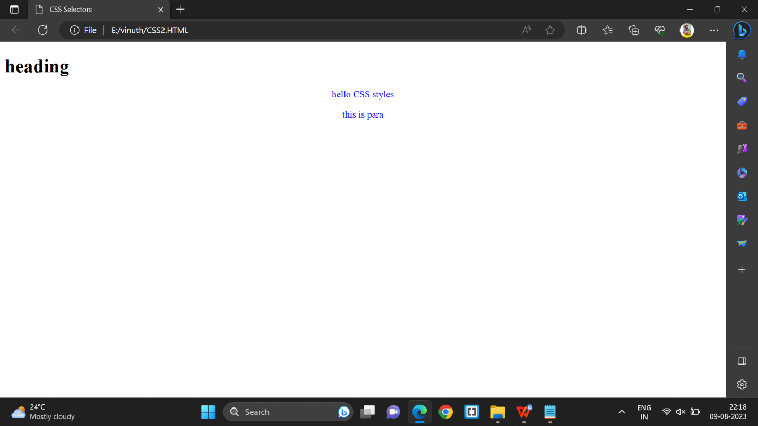

**Task 3:**

<!DOCTYPE HTML>

<html>

<head>

<style>

#para1{

text-align: right;

color: green;

}

</style>

</head>

<body>

<h1><p id="para1"> CSS id Selectors </p></h1>

<p> this is a paragraph </p>

<p> my paragraph </p>

</body>

</html>

**Output:**

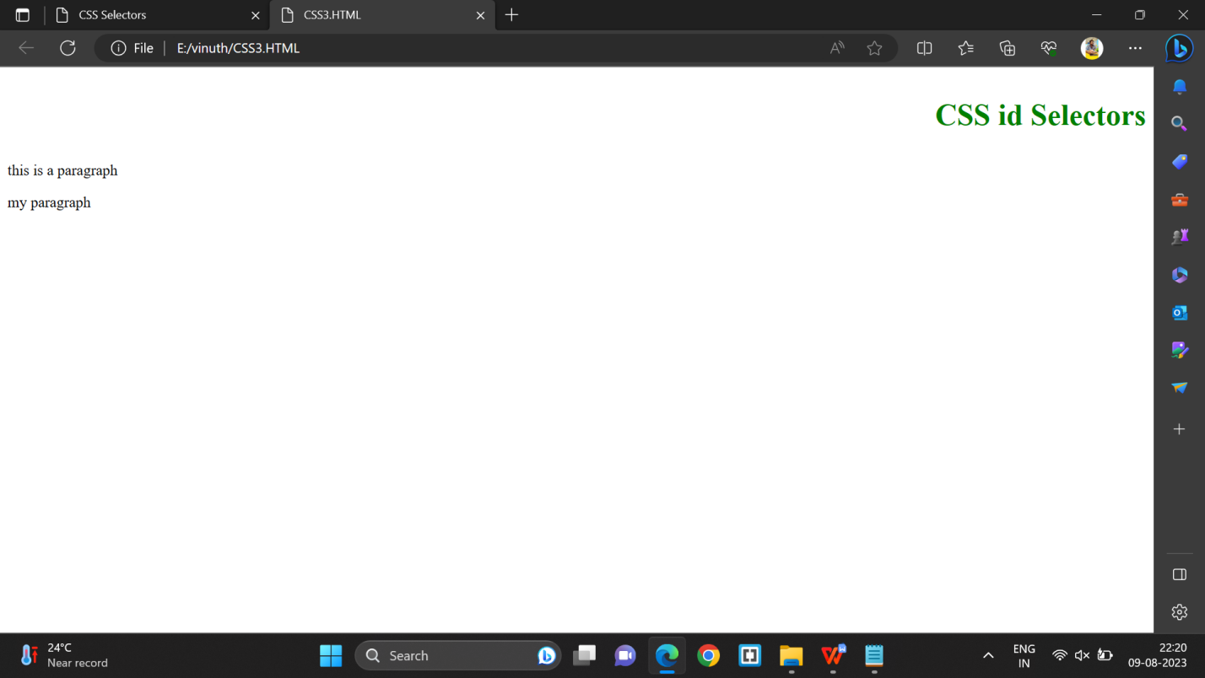

**Task 4:**

<!DOCTYPE html>

<html>

<head>

<title>HTML Nested Framesets</title>

</head>

<frameset rows="60%,*,*">

<frameset cols="50%">

<frame name="frame1" src="E:\vinuth\tree.jfif">

</frameset>

<frameset cols="*, *, *,*">

<frame name="frame2" src="E:\vinuth\winter.jfif">

<frame name="frame3" src="E:\vinuth\summer.jfif">

<frame name="frame4" src="E:\vinuth\SPRING.jfif">

</frameset>

<frame name="frame5" src="rainy.jfif">

</frameset>

</html>

**Output:**

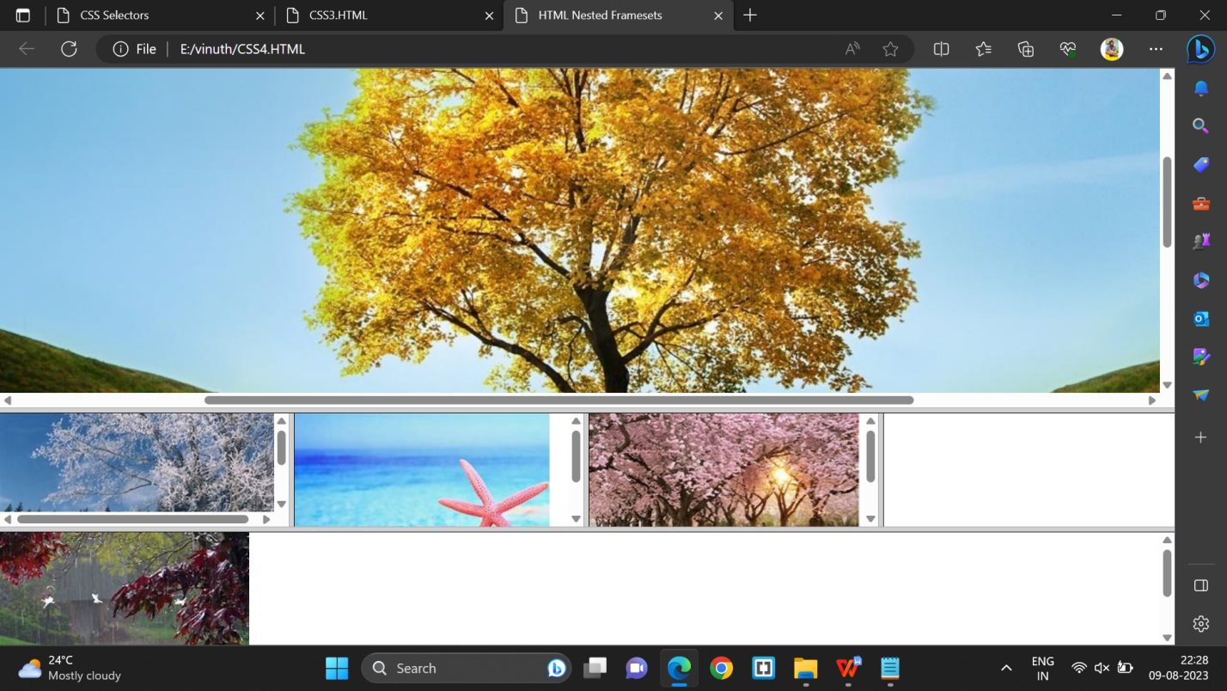

**Task 5:**

In how many ways can I add CSS to HTML? What are they? Give sample code for each?

ANS:

IN 3 ways we can write or add css to html.

they are:

1.Inline

2.External

3.Internal css

**1.Inline**

<!DOCTYPE html>

<html>

<body>

<h1 style="color:blue;text-align:center;">This is a heading</h1>

<p style="color:red;">This is a paragraph.</p>

</body>

</html>

**2.External**

<!DOCTYPE html>

<html>

<head>

<link rel="stylesheet" href="mystyle.css">

</head>

<body>

<h1>This is a heading</h1>

<p>This is a paragraph.</p>

</body>

</html>

in other tab

body {

background-color: lightblue;

}

h1 {

color: navy;

margin-left: 20px;

}

**3. Internal CSS**

<!DOCTYPE html>

<html>

<head>

<style>

body {

background-color: red;

}

h1 {

color: maroon;

margin-left: 40px;

}

</style>

</head>

<body>

<h1>This is a heading</h1>

<p>This is a paragraph</p>

</body>

</html>

**BOOTSTRAP**

**Task 1:**

what is Bootstrap? why use Bootstrap?

Bootstrap is the most popular CSS Framework for developing responsive and mobile-first websites.

In general, bootstrapping usually refers to a self-starting process that is supposed to continue or grow without external input.

Why use bootstrap?

Advantages of Bootstrap:

1.Easy to use: Anybody with just basic knowledge of HTML and CSS can start using Bootstrap

2.Responsive features: Bootstrap's responsive CSS adjusts to phones, tablets, and desktops

3.Mobile-first approach: In Bootstrap 3, mobile-first styles are part of the core framework

4.Browser compatibility: Bootstrap is compatible with all modern browsers (Chrome, Firefox, Internet Explorer, Edge, Safari, and Opera).

**Task 2:**

Create a Sample Bootstrap Page.Observe and explain what do you understand by this code.

<!DOCTYPE html>

<html lang="en">

<head>

<title>Sample Bootstrap Page</title>

<meta charset="utf-8">

<meta name="viewport" content="width=device-width, initial-scale=1">

<link rel="stylesheet" href="https://maxcdn.bootstrapcdn.com/bootstrap/3.4.1/css/bootstrap.min.css">

<script src="https://ajax.googleapis.com/ajax/libs/jquery/3.6.3/jquery.min.js"></script>

<script src="https://maxcdn.bootstrapcdn.com/bootstrap/3.4.1/js/bootstrap.min.js"></script>

</head>

<body>

<div class="jumbotron text-center">

<h1>Prasunamba's Bootstrap Page</h1>

<p>Use this responsive page to see the effect - it will resize !</p>

</div>

<div class="container">

<div class="row">

<div class="col-sm-4">

<h3>Column 1</h3>

<p>this is Paragraph 1....................</p>

<p>This is Paragraph 2 ......................</p>

</div>

<div class="col-sm-4">

<h3>Column 2</h3>

<p>this is Paragraph 3....................</p>

<p>This is Paragraph 4 ......................</p>

<div class="col-sm-4">

<h3>Column 3</h3>

<p>this is Paragraph 5....................</p>

<p>This is Paragraph 6 ......................</p>

</div>

</div>

</div>

</body>

</html>

**Output:**

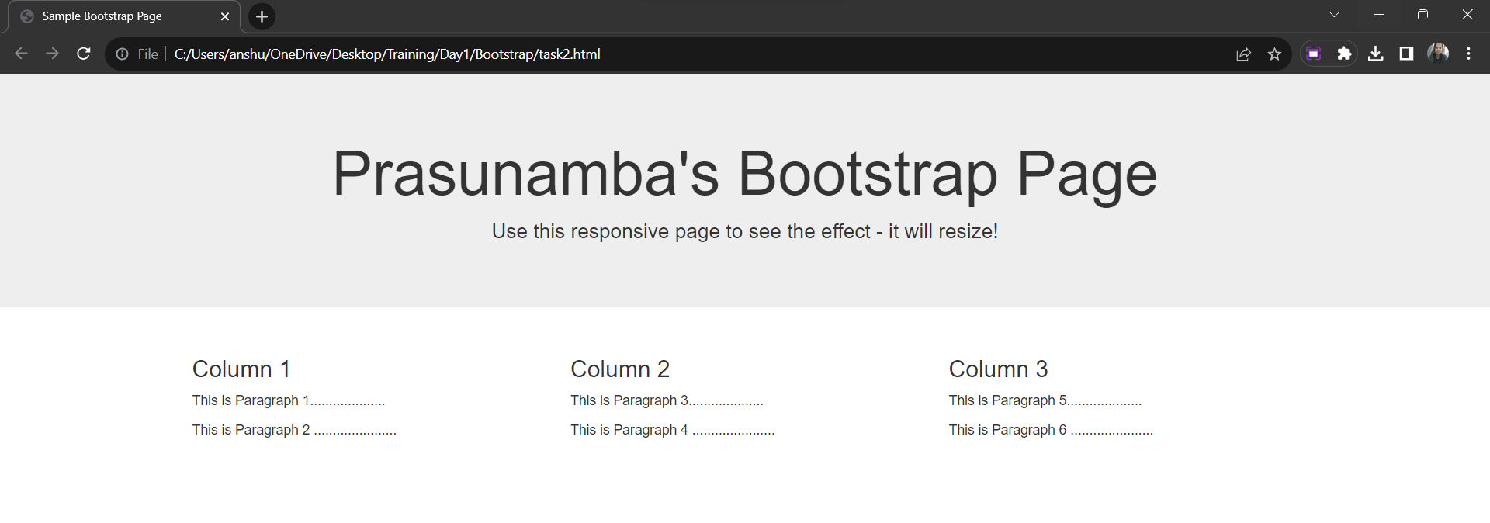

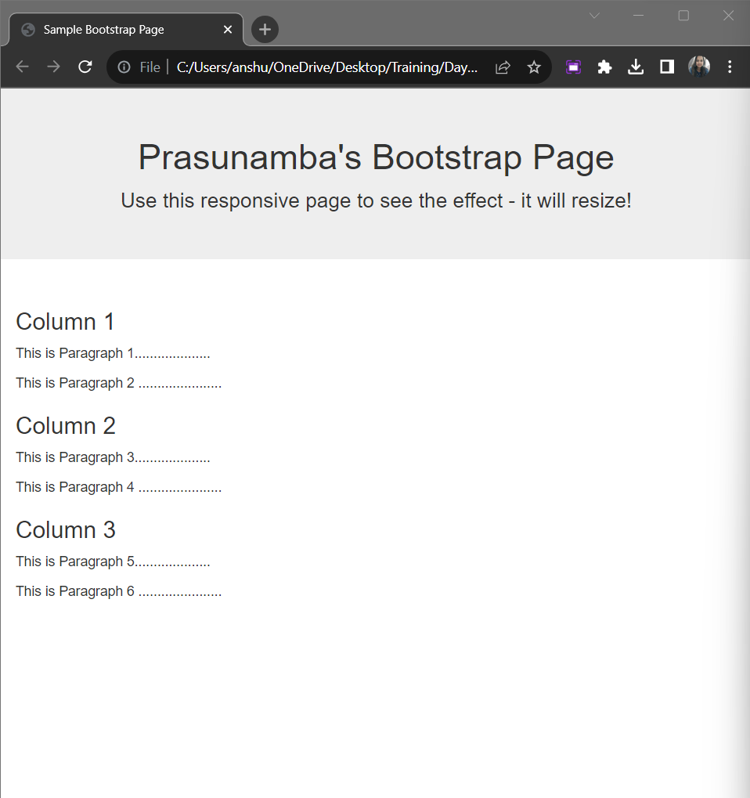

Observation :

* The `<div>` with the class `jumbotron` creates a visually prominent header section at the top of the page. It contains a centered heading and a descriptive paragraph.
* The use of Bootstrap's grid system and responsive classes (`col-sm-4`) allows the columns to automatically adjust their layout based on the screen size. On smaller screens, the columns stack vertically, providing an optimized user experience on various devices.
* The use of Bootstrap classes (`jumbotron`, `container`, `row`, `col-sm-4`) simplifies layout and styling. These classes provide consistent styling and responsive behavior without the need for extensive custom CSS.

**Task 3:**

there are 7 different types of buttons are there:

basic

primary

default

success

info

warning

danger

code :

<!DOCTYPE html>

<html lang="en">

<head>

<title>Bootstrap Example</title>

<meta charset="utf-8">

<meta name="viewport" content="width=device-width, initial-scale=1">

<link rel="stylesheet" href="https://maxcdn.bootstrapcdn.com/bootstrap/3.4.1/css/bootstrap.min.css">

<script src="https://ajax.googleapis.com/ajax/libs/jquery/3.6.4/jquery.min.js"></script>

<script src="https://maxcdn.bootstrapcdn.com/bootstrap/3.4.1/js/bootstrap.min.js"></script>

</head>

<body>

<div class="container">

<h2>Button Styles</h2>

<button type="button" class="btn">Basic</button><br>

<button type="button" class="btn btn-default">Default</button><br>

<button type="button" class="btn btn-primary">Primary</button><br>

<button type="button" class="btn btn-success">Success</button><br>

<button type="button" class="btn btn-info">Info</button><br>

<button type="button" class="btn btn-warning">Warning</button><br>

<button type="button" class="btn btn-danger">Danger</button><br>

<button type="button" class="btn btn-link">Link</button><br>

</div>

</body>

</html><br>

<br>

**Output:**

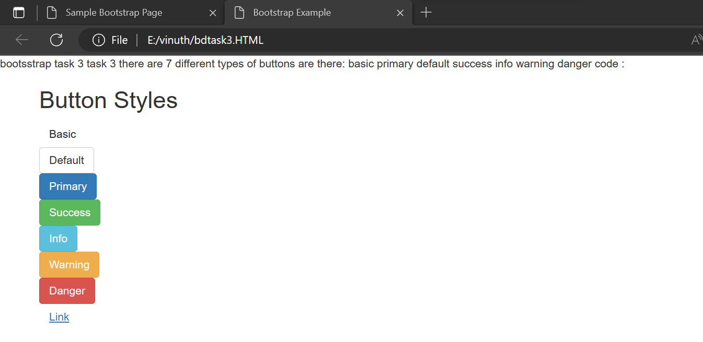

**Task 4:**

<!DOCTYPE html>

<html lang="en">

<head>

<title>Bootstrap Example</title>

<meta charset="utf-8">

<meta name="viewport" content="width=device-width, initial-scale=1">

<link href="https://cdn.jsdelivr.net/npm/bootstrap@5.3.1/dist/css/bootstrap.min.css" rel="stylesheet">

<script src="https://cdn.jsdelivr.net/npm/bootstrap@5.3.1/dist/js/bootstrap.bundle.min.js"></script>

</head>

<body>

<div class="container mt-3">

<h2>Alerts</h2>

<p>Alerts are created with the .alert class, followed by a contextual color classes:</p>

<div class="alert alert-success">

<strong>Success!</strong> This alert box could indicate a successful or positive action.

</div>

<div class="alert alert-info">

<strong>Info!</strong> This alert box could indicate a neutral informative change or action.

</div>

<div class="alert alert-warning">

<strong>Warning!</strong> This alert box could indicate a warning that might need attention.

</div>

<div class="alert alert-danger">

<strong>Danger!</strong> This alert box could indicate a dangerous or potentially negative action.

</div>

</body>

</html>

**Output:**

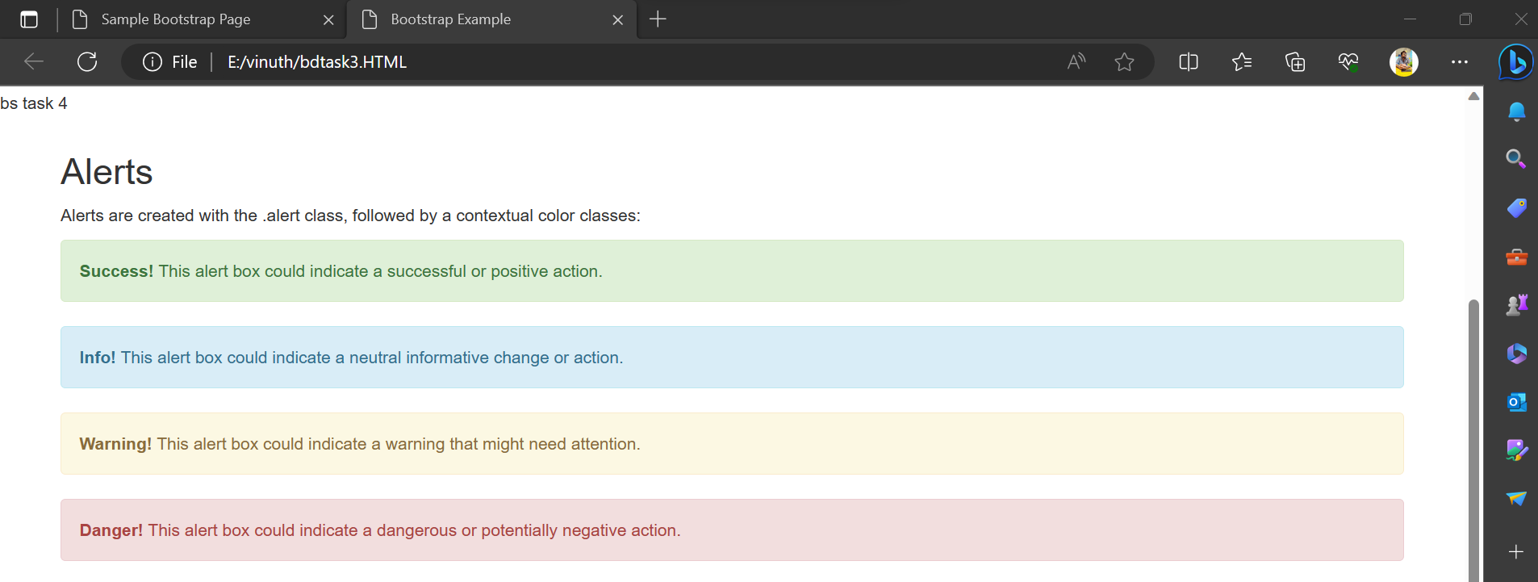

**Task 5:**

Task 5:

Sample codes for ur understanding

Grid system use

<!DOCTYPE html>

<html lang="en">

<head>

<title>Bootstrap Example</title>

<meta charset="utf-8">

<meta name="viewport" content="width=device-width, initial-scale=1">

<link rel="stylesheet" href="https://maxcdn.bootstrapcdn.com/bootstrap/3.4.1/css/bootstrap.min.css">

<script src="https://ajax.googleapis.com/ajax/libs/jquery/3.6.3/jquery.min.js"></script>

<script src="https://maxcdn.bootstrapcdn.com/bootstrap/3.4.1/js/bootstrap.min.js"></script>

</head>

<body>

<div class="container-fluid">

<h1>Hello World!</h1>

<p>Resize the browser window to see the effect.</p>

<p>The columns will automatically stack on top of each other when the screen is less than 768px wide.</p>

<div class="row">

<div class="col-lg-2" style="background-color:lavender;">.col-sm-4</div>

<div class="col-lg-6" style="background-color:lavenderblush;">.col-sm-4</div>

<div class="col-lg-4" style="background-color:lavender;">.col-sm-4</div>

</div>

</div>

</body>

</html>

**Output:**

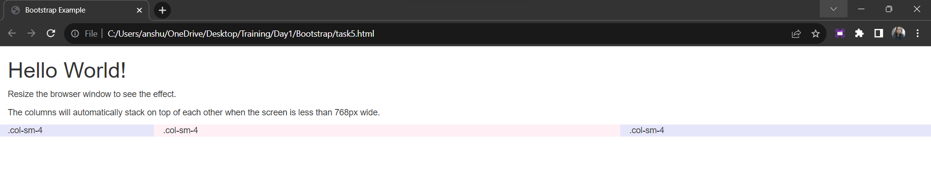

Output after resizing:

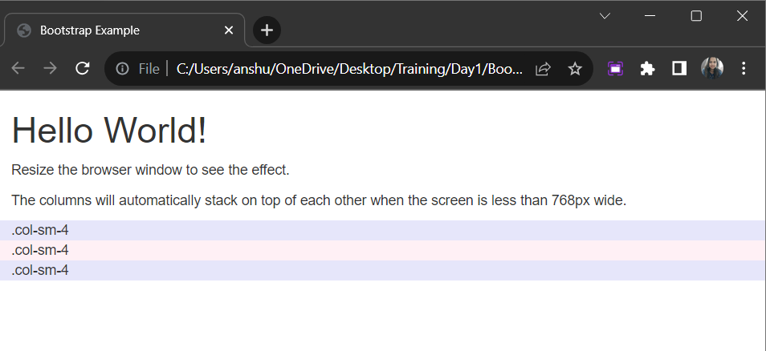

* The columns (col-lg-2, col-lg-6, and col-lg-4) use Bootstrap's grid classes to specify their widths for large screens.
* The style attribute is used to apply background colors to the columns for visual distinction.
* When we load this HTML page in a web browser, you'll see a layout with three columns.
* On larger screens, the columns have specific widths (col-lg-2, col-lg-6, and col-lg-4).
* As we resize the browser window to a smaller width, the columns will stack vertically on top of each other when the screen width is less than 768px .
* This behavior showcases Bootstrap's responsive design and how the grid system adapts the layout based on the screen size.

**Task 6:**

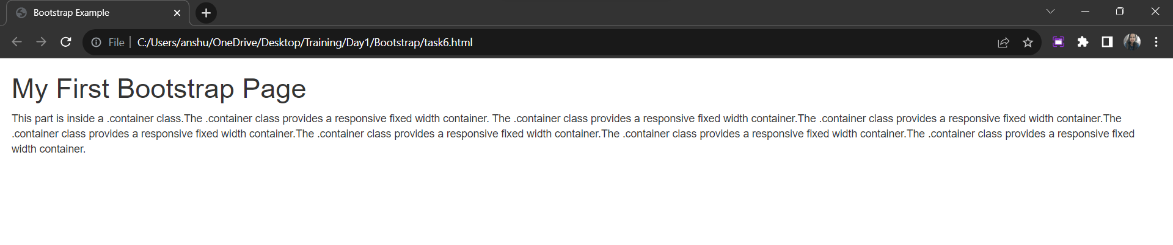

Output after resizing:

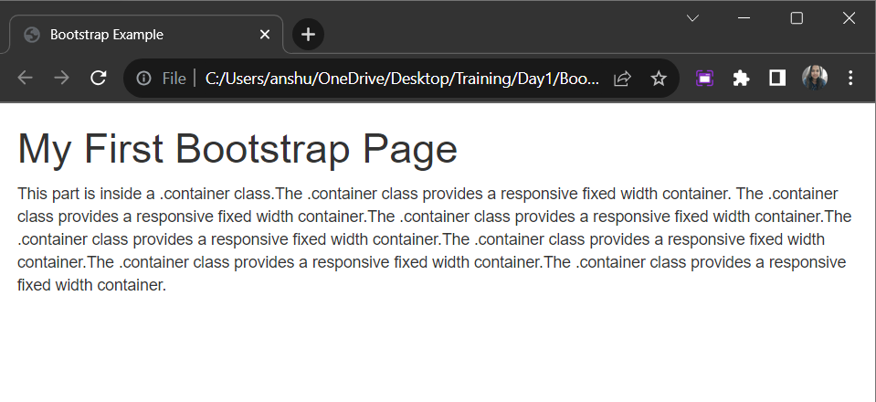

Observation :

* The page displays a heading <h1> with the text "My First Bootstrap Page" and a paragraph <p> containing a series of sentences.
* The content is contained within a responsive full-width container created using the .container-fluid class.
* The text inside the paragraph describes the use of the .container class, highlighting its ability to provide a responsive fixed-width container that maintains a consistent width across different screen sizes.
* We see the heading and paragraph content displayed within a responsive full-width container.
* The container spans the entire width of the viewport, providing a visually consistent experience across different devices and screen sizes.

**Task 7:**

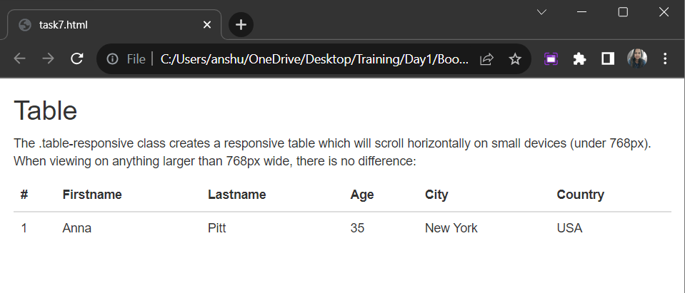

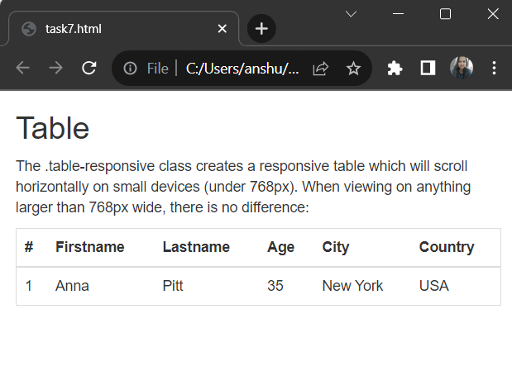

Observation :

* The page displays a title <h2> with the text "Table" and a description <p> that explains the purpose of the .table-responsive class.
* Below the description, a responsive table is displayed with column headers and data.
* The table is contained within a <div> with the class table-responsive, ensuring that the table will scroll horizontally on smaller screens (less than 768px width) to make all content visible.
* When we load this HTML page in a web browser, we will see a responsive table. If our screen is narrower than 768px, we will notice that the table content will scroll horizontally to maintain visibility. This behavior ensures that users on smaller devices can access all the table.
* On screens wider than 768px, the table layout remains unchanged.

Home Tasks: Source Code:

<html>

<head>

   <title>Too Yumm!!</title>

  <link rel="stylesheet’’ href="https://maxcdn.bootstrapcdn.com/bootstrap/4.5.2/css/bootstrap.min.css">

  <style>

    body {

      font-family: Arial, sans-serif;

      background-color: #418ad3;

    }

    .navbar {

      background-color: #343a40;

    }

    .navbar-dark .navbar-nav .nav-link {

      color: #fff;

    }

    .hero {

      background-image: url('color.jpg');

      background-size: cover;

      color: #fff;

      text-align: center;

      padding: 150px 0;

    }

    .menu {

      padding: 80px 0;

      background-color: #fff;

    }

    .menu-item {

      margin-bottom: 20px;

    }

    .reservation {

      padding: 80px 0;

      background-color: #f8f9fa;

    }

    .contact {

      padding: 80px 0;

    }

  </style>

</head>

<body>

<nav class="navbar navbar-expand-md navbar-dark">

  <a class="navbar-brand" href="#">Too Yumm !!</a>

  <button class="navbar-toggler" type="button" data-toggle="collapse" data-target="#navbarNav" aria-controls="navbarNav" aria-expanded="false" aria-label="Toggle navigation">

    <span class="navbar-toggler-icon"></span>

  </button>

  <div class="collapse navbar-collapse" id="navbarNav">

    <ul class="navbar-nav ml-auto">

      <li class="nav-item">

        <a class="nav-link" href="#hero">Home</a>

      </li>

      <li class="nav-item">

        <a class="nav-link" href="#menu">Menu</a>

      </li>

      <li class="nav-item">

        <a class="nav-link" href="#reservation">Reservation</a>

      </li>

      <li class="nav-item">

        <a class="nav-link" href="#contact">Contact</a>

      </li>

    </ul>

  </div>

</nav>

<section class="hero" id="hero">

  <h1>Too Yummm !!</h1>

  <p>Indulge in a delightful culinary experience.</p>

  <a href="#reservation" class="btn btn-primary btn-lg">Make a Reservation</a>

</section>

<section class="menu" id="menu">

  <div class="container">

    <h2>Our Menu</h2>

    <div class="row">

      <div class="col-md-4">

        <div class="menu-item">

          <img src="appetizer.jpg" height="600" width="400" alt="Menu Item" class="img-fluid">

          <h3>Appetizers</h3>

          <p>Delicious starters to tantalize your taste buds.</p>

        </div>

      </div>

      <div class="col-md-4">

        <div class="menu-item">

          <img src="main.jpg" height="600" width="400" alt="Menu Item" class="img-fluid">

          <h3>Main Courses</h3>

          <p>Savory and hearty dishes that satisfy your cravings.</p>

        </div>

      </div>

      <div class="col-md-4">

        <div class="menu-item">

          <img src="dessert.jpg" height="400" width="400" alt="Menu Item" class="img-fluid">

          <h3>Desserts</h3>

          <p>Sweet treats to complete your dining experience.</p>

        </div>

      </div>

    </div>

  </div>

</section>

<section class="reservation" id="reservation">

  <div class="container">

    <h2>Make a Reservation</h2>

    <form>

      <div class="form-row">

        <div class="form-group col-md-6">

          <label for="name">Name:</label>

          <input type="text" class="form-control" id="name" required>

        </div>

        <div class="form-group col-md-6">

          <label for="email">Email:</label>

          <input type="email" class="form-control" id="email" required>

        </div>

      </div>

      <div class="form-row">

        <div class="form-group col-md-6">

          <label for="date">Date:</label>

          <input type="date" class="form-control" id="date" required>

        </div>

        <div class="form-group col-md-6">

          <label for="time">Time:</label>

          <input type="time" class="form-control" id="time" required>

        </div>

      </div>

      <button type="submit" class="btn btn-primary">Submit Reservation</button>

    </form>

  </div>

</section>

<footer class="text-center p-4 bg-dark text-white" id="contact">

  <div class="container">

    <div class="row">

      <div class="col-md-6">

        <h4>Contact Information</h4>

        <p>123 Main Street, Bangalore</p>

        <p>Email: yumm@restaurant.com</p>

        <p>Phone: 96610*****</p>

      </div>

    </div>

  </div>

</footer>

<script src="https://kit.fontawesome.com/a076d05399.js" crossorigin="anonymous"></script>

<script src="https://code.jquery.com/jquery-3.5.1.slim.min.js"></script>

<script src="https://cdn.jsdelivr.net/npm/@popperjs/core@2.9.1/dist/umd/popper.min.js"></script>

<script src="https://maxcdn.bootstrapcdn.com/bootstrap/4.5.2/js/bootstrap.min.js"></script>

</body>

</html>

Output :

